# Ch4 - Social Perception and Managing Diversity.

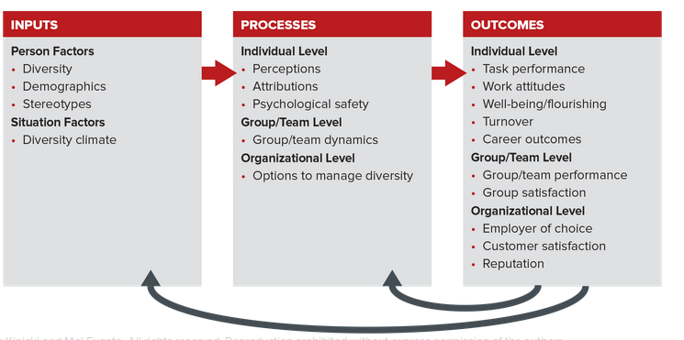

## 4.1 - PERSON Perception,

Perception is key to resolving the above questions. Perception is a cognitive process that enables us to interpret and understand our surroundings. Recognition of objects is one of this process’s major functions. But because organizational behavior’s (OB’s) principal focus is on people, our discussion will emphasize person perception rather than object perception.

Perception is important to OB because behavior is based on our perception of reality, not on reality itself. Our exploration of this important process begins by considering a model of person perception. The model provides a practical framework for understanding how we form perceptions of others. We then consider the managerial implications of person perception.

Perception is influenced by three key components: the characteristics of the perceiver, of the target, the person or group being observed, and of the situation (see Figure 4.2).

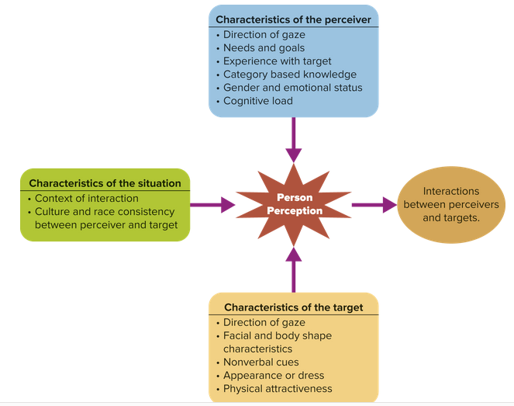

Hiring.

Interviewers make hiring decisions based on their impression of how an applicant fits the perceived requirements of a job. Unfortunately, many of these decisions are made on the basis of implicit cognition. Implicit cognition represents any thoughts or beliefs that are automatically activated from memory without our conscious awareness. The existence of implicit cognition leads people to make biased decisions without realizing they are doing so. A recent study of job applicants’ résumés, for instance, demonstrated that recruiters evaluated women more favorably than men for customer service jobs, probably based on gender-role stereotypes.

Performance Appraisal

Faulty perceptions about performance can lead to inaccurate performance appraisals, which erode morale. Consider the results of a recent study of commanding officers in the US military.

The research looked at 193 commanding officers who were assigned legal advisers. The advisers were all professionals with a law degree, and the commanding officers were responsible for conducting their performance evaluations. On average, female advisers received lower performance ratings than males as their pay grade approached that of the boss. Male advisers did not have this experience. The only good news from the study is that this form of bias occurred only when evaluators had high social dominance orientation, a personal characteristic in which someone prefers to dominate other groups of people, in this case women.

Perceptual biases in performance appraisals can be reduced by the use of more objective measures of performance. While this is a good idea, it is hard to implement for jobs that require interdependent work, mental work, or work that does not produce objective outcomes.

Companies can also reduce bias by providing managers a mechanism for accurately recalling employee behavior, such as a performance diary. Finally, it would be useful to train managers about perceptual biases and about how they can avoid them in performance evaluations.

Leadership

Research demonstrates that employees’ evaluations of leader effectiveness are influenced strongly by their categorical knowledge of what constitutes good and poor leaders. For example, a team of researchers found that the following behaviors are representative of effective leadership:

1. Assigning specific tasks to group members.
2. Telling others they have done well.
3. Setting specific goals for the group.
4. Letting other group members make decisions.
5. Trying to get the group to work as a team.
6. Maintaining definite standards of performance.

## 4.2 – Stereotypes,

“A stereotype is an individual’s set of beliefs about the characteristics or attributes of a group.”27 We need to recognize how stereotypes affect our perception because we use them without intending to or even being consciously aware that we are.

Unfortunately, stereotypes can lead to poor decisions. Consider people diagnosed with cancer, about 40 percent of men and women living in the United States. A recent study of the retail industry showed that managers made discriminatory decisions about individuals whose job applications indicated they were cancer survivors. All told, stereotypes can create barriers for women, older individuals, people of color, and people with disabilities, all while undermining loyalty and job satisfaction. Let’s look at examples.

Gender. A summary of research revealed that:

Men were preferred for male-dominated jobs (e.g., firefighters), but there was no preference for either gender in female-dominated jobs (e.g., nurse).

Women have a harder time than men in being perceived as effective leaders. (The exception: Women were seen as more effective when the organization faced a crisis and needed a turnaround.)

Women of color are more negatively affected by sex-role stereotypes than are white women or men in general.

Race. Studies of race-based stereotypes demonstrated that people of color experienced more perceived discrimination and less psychological support than whites. Perceived racial discrimination was also associated with more negative work attitudes, physical health, psychological health, and organizational citizenship behavior.

Age. Another example of an inaccurate stereotype is the belief that older workers are less motivated, more resistant to change, less trusting, less healthy, and more likely to have problems with work–life balance. A recent study refuted all these negative beliefs about age.

Stereotype Formation and Maintenance

We build stereotypes through a four-step process:

1. Categorization. We categorize people into groups according to criteria (such as gender, age, race, and occupation).
2. Inferences. Next, we infer that all people within a particular category possess the same traits or characteristics: women are nurturing, older people have more job-related accidents, African Americans are good athletes.
3. Expectations. We form expectations of others and interpret their behavior according to our stereotypes.
4. Maintenance. We maintain stereotypes by:
   1. Overestimating the frequency of stereotypic behaviors exhibited by others.
   2. Incorrectly explaining expected and unexpected behaviors.
   3. Differentiating minority individuals from ourselves.

Managerial Challenges and Recommendations

The key managerial challenge is to reduce the extent to which stereotypes influence decision making and interpersonal processes throughout the organization. We suggest three ways that this can be achieved.

1. Managers should educate people about stereotypes and how they can influence our behavior and decision making. Many people may not understand how stereotypes unconsciously affect their perception. For example, people evaluating symphony orchestra musicians for jobs were found to be biased toward men. This unconscious tendency was reduced by using a curtain to block the evaluation committee from seeing applicants. Significantly more females were hired under this unbiased approach.
2. Managers should create opportunities for diverse employees to meet and work together in cooperative groups of equal status. Social scientists believe positive interpersonal contact among mixed groups is the best way to reduce stereotypes because it provides people with more accurate data about the characteristics of others.
3. Managers should encourage all employees to increase their awareness of stereotypes. Awareness helps reduce the application of stereotypes when making decisions and interacting with others.

## 4.3 Causal Attributions,

Attribution theory is based on a simple premise: Rightly or wrongly, people infer causes for their own and others’ behavior. Formally defined, causal attributions are suspected or inferred causes of behavior. Managers need to understand how people formulate these attributions because they profoundly affect organizational behavior. Consider Table 4.1, in which the manager’s understanding of observed behavior leads to very different actions.

Kelley’s Model of Attribution

Current models of attribution build on the pioneering work of the late Fritz Heider. Heider, the founder of attribution theory, proposed that behavior can be attributed either to internal factors within a person (such as ability) or to external factors within the environment (such as a difficult task). Following Heider’s work, Harold Kelley attempted to pinpoint some specific antecedents of internal and external attributions. Kelley hypothesized that people make causal attributions by observing three dimensions of behavior: consensus, distinctiveness, and consistency. These dimensions vary independently, forming various combinations and leading to differing attributions.

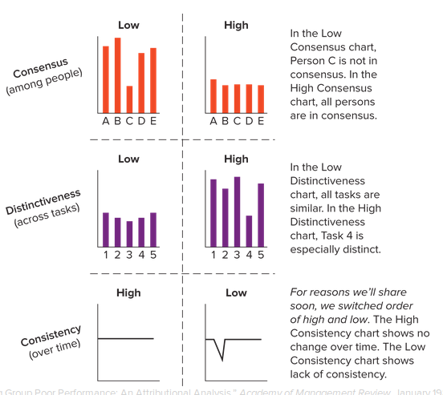

How do these three dimensions of behavior lead to specific attributions? Kelley theorized that people attribute behavior to either internal causes (personal factors) or external causes (environmental factors) depending on the way they rank consensus, distinctiveness, and consistency as shown in Table 4.2

Fundamental Attribution Bias.

The fundamental attribution bias reflects our tendency to attribute another person’s behavior to his or her personal characteristics, rather than to situation factors. This bias causes perceivers to ignore important environmental factors (again refer to the Organizing Framework), which often significantly affect behavior. Such bias leads to inaccurate assessments of performance, which in turn fosters inappropriate responses to poor performance.

Self-Serving Bias.

The self-serving bias represents our tendency to take more personal responsibility for success than for failure. The self-serving bias suggests employees will attribute their success to internal factors (high ability or hard work) and their failures to uncontrollable external factors (tough job, bad luck, uncooperative coworkers or boss). This tendency plays out in all aspects of life.

Managerial Applications and Implications

Attribution models can explain how managers handle poorly performing employees. One study revealed that managers gave employees more immediate, frequent, and negative feedback when they attributed their performance to low effort. Another indicates that managers tended to transfer employees whose poor performance they attributed to a lack of ability. These same managers also decided to take no immediate action when poor performance was attributed to external factors beyond an individual’s control.

## 4.4 - Defining and Managing Diversity,

Do you have any preconceived notions about diversity that are worth considering? Let’s take a reality check:

Assumption: Gender diversity on boards of directors does not affect firm performance. Wrong, says a team of researchers who aggregated results from 140 research studies. Findings showed that firms were more profitable when women were members of the board of directors.

Assumption: Organizations had a hard time finding qualified employees during the 2014–2015 slow-growth economy. Yes, according to 2015 data from Indeed.com, the top employment-related website in the world. It seems that 56 percent of all job openings remained open after one month, and 33 percent were still active after three months. All told, Indeed.com estimated in 2015 that “over 330 million working hours are lost every month in the United States from unfilled job openings.” The most difficult jobs to fill across all industries were managerial and supervisory.

Assumption: Whites will constitute the majority among US racial groups through 2050. No, according to the US Census Bureau. Today whites represent 63 percent of the population, but that will drop below 50 percent in 2043.42

The United States is becoming more diverse in its gender, racial, educational, and age makeup. For example, there are now more working parents, more nonwhites, and more older people, and the consequences are not always what you might expect. Demographics are the statistical measurements of populations and their qualities (such as age, race, gender, or income) over time. The study of demographics helps us better appreciate diversity and helps managers develop human resource policies and practices that attract, retain, and develop qualified employees. In the remainder of this chapter we will further your understanding of diversity and its managerial challenges.

Layers of Diversity

Diversity represents the multitude of individual differences and similarities that exist among people, making it an input in the Organizing Framework for Understanding and Applying OB. As you will learn, however, managing diversity also affects a variety of processes and outcomes within the Organizing Framework.

Moreover, diversity pertains to everybody. It is not just an issue of age, race, or gender; of being heterosexual, gay, or lesbian; or of being Catholic, Jewish, Protestant, or Muslim. Diversity pertains to the host of individual differences that make each of us unique and different from all others.

Lee Gardenswartz and Anita Rowe, a team of diversity experts, identified four layers of diversity to help distinguish the important ways in which people differ (see Figure 4.4). Taken together, these layers define our personal identities and influence the way each of us sees the world.

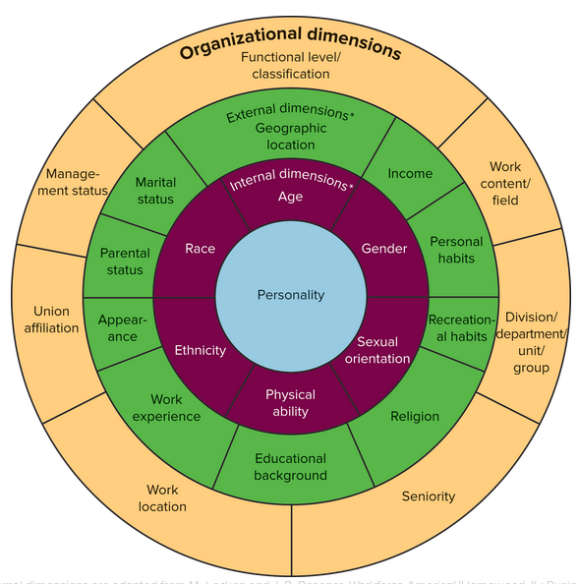

Figure 4.4 shows that the next layer of diversity consists of external influences. These are individual differences over which we have more control, such as where we live, our religious affiliation, our marital and parental status, and our work experience. These dimensions also exert a significant influence on our perceptions, behavior, and attitudes.

Affirmative Action

Affirmative action is not a law in and of itself. It is an outgrowth of equal employment opportunity (EEO) legislation. The goal of this legislation is to outlaw discrimination and to encourage organizations to proactively prevent discrimination. Discrimination occurs when employment decisions about an individual are based on reasons not associated with performance or related to the job. For example, organizations cannot legally discriminate on the basis of race, color, religion, national origin, sex, age, physical and mental disabilities, and pregnancy. Affirmative action is an intervention aimed at giving management a chance to correct an imbalance, injustice, mistake, or outright discrimination that occurred in the past.

Affirmative action.

* Can refer to both voluntary and mandatory programs.
* Does not legitimize quotas. Quotas are illegal and can be imposed only by judges who conclude that a company has engaged in discriminatory practices.
* Does not require companies to hire unqualified people.
* Has created tremendous opportunities for women and minorities.
* Does not foster the type of thinking needed to manage diversity effectively.

Managing diversity enables people to perform to their maximum potential. Diversity management focuses on changing an organization’s culture and infrastructure such that people work to the highest productivity possible. Ann Morrison, a diversity expert, attempted to identify the types of initiatives 16 companies used to successfully manage diversity. Her results found three key strategies at work: education, enforcement, and exposure. She describes them as follows:

* The educational component. Education “has two thrusts: one is to prepare nontraditional managers for increasingly responsible posts, and the other is to help traditional managers overcome their prejudice in thinking about and interacting with people who are of a different sex or ethnicity.”
* The enforcement component. Enforcement “puts teeth in diversity goals and encourages behavior change.”50
* The exposure component. Exposing people to others with different backgrounds and characteristics “adds a more personal approach to diversity by helping managers get to know and respect others who are different.”51

In summary, both consultants and academics believe organizations should strive to manage diversity rather than being forced to use affirmative action.

## 4.5 - Building the Business Case for Managing Diversity,

Business Rationale.

The rationale for managing diversity is more than the fact that it’s legally, socially, or morally desirable. Quite simply, it’s good business. The OB in Action box illustrates how companies can gain competitive advantage by producing products targeted at specific demographic groups, in this case, men who do laundry.

An access-and-legitimacy perspective on diversity is based in recognition that the organization’s markets and constituencies are culturally diverse. It therefore behooves the organization to match the diversity in parts of its own workforce as a way of gaining access to and legitimacy with those markets and constituent groups.

Women Break the Glass Ceiling, but Navigate a Labyrinth.

Coined in 1986, the term glass ceiling identifies an invisible but absolute barrier that prevents women from advancing to higher-level positions. Various statistics support the existence of the glass ceiling. Take the pay gap between men and women, for example. In 2014, the median weekly income in full-time management, professional, and related occupations was $1,346 for men but $981 for women. Even among female and male MBA graduates who made about the same upon graduation in 2007–2009, by 2014 a gap had opened, women earned $140,000 and men $175,000.

Alice Eagly and Linda Carli conducted a thorough investigation into the organizational life of women and in 2007 published their conclusions that women had finally broken through the glass ceiling. We’ve updated the data reported in Eagly and Carli’s book that led them to their conclusion. In 2016 there were many more female CEOs (21 within the Fortune 500 and two more expected by late 2016) and more women in managerial, professional, and related occupations than in the 1980s and 1990s. Statistics further showed that women had made strides along several measures.

1. Educational attainment: Women earned the majority of bachelor’s and master’s degrees in 2014.
2. Seats on boards of directors of Fortune 500 firms: Women held 9.6 percent of seats in 1995 and 19.7 percent in 2015.
3. Leadership positions in educational institutions and Congress: In 2016 women represented 23 percent of college presidents, and in 2014, 100 women served in Congress, the largest number ever.
4. Federal court appointments: In 2016, 35 percent of federal courts of appeals judges were female.

You can interpret the above statistics in one of two ways.

* No Change. On the one hand, you might see proof that women remain underpaid and underrepresented in leadership positions, victims of discriminatory organizational practices.
* Positive Change. Or you can agree with Eagly and Carli’s conclusion that “men still have more authority and higher wages, but women have been catching up. Because some women have moved into the most elite leadership roles, absolute barriers are a thing of the past.”

Racial Groups Face Their Own Glass Ceiling and Perceived Discrimination

The US workforce is becoming increasingly diverse. Between 2012 and 2060, the Census Bureau predicts the following changes in ethnic representation:

* Growth: The Asian population will grow from 5.1 percent to 8.2 percent of the total.
* Growth: The Hispanic population will grow from 17 percent to 31 percent.
* Mild growth: The African American population will rise from 13.1 percent to 14.7 percent.
* Decline: Non-Hispanic whites will drop from 63 percent to 43 percent.

In 2060 so-called minority groups will constitute approximately 57 percent of the workforce, according to the Census Bureau. And yet three additional trends suggest that current-day minority groups are stalled at their own glass ceilings:

Smaller percentage in the professional class. Hispanics, or Latinas/os, and African Americans have a smaller relative hold on managerial and professional jobs compared with whites. Women of color generally do better than men of color.

More discrimination cases. The number of race-based charges of discrimination that were deemed to show reasonable cause by the US Equal Employment Opportunity Commission increased from 294 in 1995 to 678 in 2015. Companies paid a total of $88.4 million to resolve these claims without litigation in 2015.

Lower earnings. Minorities also tend to earn less personal income than whites. In 2015 median weekly earnings for workers 16 years and older were $847, $643, $1,091, and $624 for whites, blacks, Asians, and Hispanics, respectively. Asians had the highest median income.

Sexual Orientation: LGBTQ People Become More Visible

The term LGBT is a widely recognized acronym to represent lesbian, gay, bisexual, and transgender. However a fifth letter has been gaining acceptance, Q, which according to the Human Rights Campaign can mean either “questioning” or “queer.”

Q for “questioning” refers to someone in the process of exploring his or her sexual identity. “People use the term queer because it’s not specific to sexual orientation or to gender identify but is more of an umbrella term that can encompass a lot of people.” You may want to avoid using the term queer because it is offensive to some in the LGBT community.

We are discussing sexual orientation because organizations cannot afford to allow between 1.2 and 6.8 percent of the workforce to feel disenfranchised. This represents the estimated number of people who identify as LGBT.

Because LGBTQ employees often experience a lack of inclusion, their engagement, performance, and retention can be affected. A study by the Human Rights Campaign Foundation, for instance, revealed that unwelcoming environments can lead to a 30 percent decrease in employee engagement and an increase in turnover. Nine percent of LGBT employees reported leaving a job because of unwelcoming work environments.

The good news is that a majority of Fortune 500 companies offer workplace protections on the basis of sexual orientation and gender identify. In contrast, 29 states do not offer such protections.

Physical and Mental Abilities: People with Disabilities Face Challenges

Approximately 20 percent of Americans have a physical or cognitive disability, according to the US Census Bureau. The Americans with Disabilities Act prohibits discrimination against those with disabilities and requires organizations to reasonably accommodate an individual’s disabilities.

Generational Differences in an Aging Workforce

The US population and workforce are getting older, and the workforce includes greater generational differences than ever before. We already see four generations of employees working together, soon to be joined by a fifth (see Table 4.3). Managers need to deal effectively with generational differences in values, attitudes, and behaviors. Many companies, including IBM, Lockheed Martin, Ernst & Young LLP, and Aetna, address this issue by providing training workshops on generational diversity.

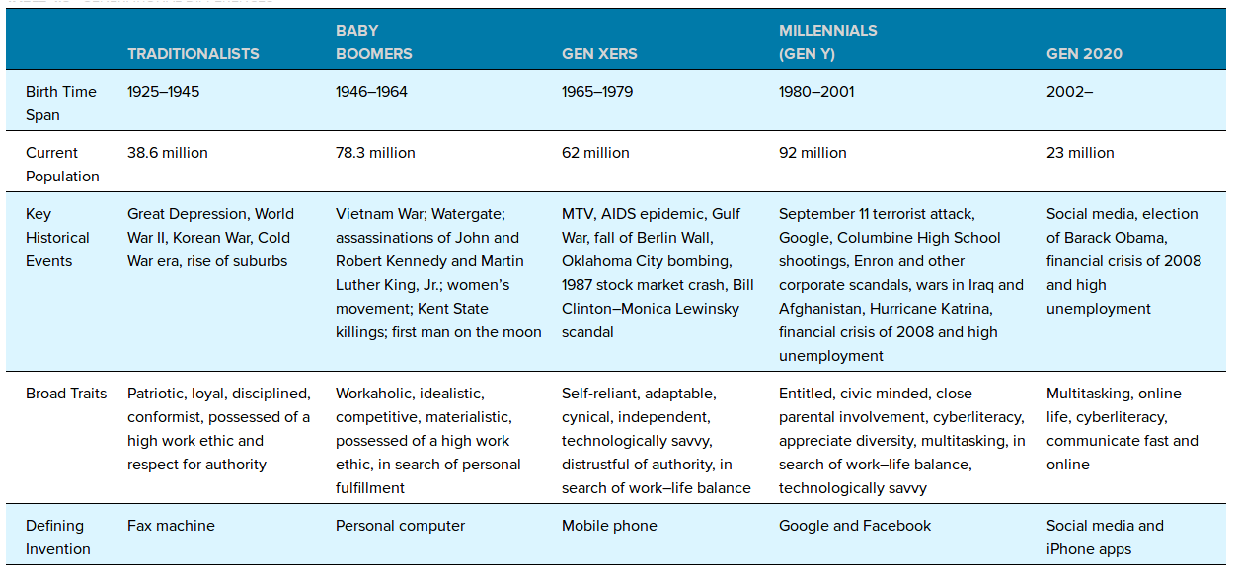

Table 4.3 summarizes generational differences using common labels: traditionalists, baby boomers, Gen Xers, Millennials/Gen Ys, and the incoming Gen 2020s. We use such labels (and resulting generalizations) for sake of discussion. There are always exceptions to the characterizations shown in Table 4.3.

Educational Levels: Mismatch between Education and Organizational Needs

There are three potential education–work mismatches:

* College graduates may be in jobs for which they are overqualified. The US Census Bureau estimates that 26.8 percent of the US workforce has at least a college degree. Unfortunately, about a half a million college graduates are working minimum-wage jobs, 260,000 with bachelor’s degrees and 200,000 with associate’s degrees. These graduates are underemployed, working at jobs that require less education than they have such as waiting tables, tending bar, painting, and other work that someone with less education could perform. Underemployment is associated with poorer work attitudes, job performance, job satisfaction, motivation, and psychological well-being.
* College graduates may not have the skills desired by employers. Recent studies show that college graduates, while technically and functionally competent, lack teamwork skills, critical-thinking ability, oral communication skills, and analytic reasoning. There is also a shortage of college graduates in technical fields related to science, math, and engineering.
* High-school dropouts and others may not have the literacy skills needed for many jobs. A recent study revealed that 7 percent of all US students between 16 and 24 dropped out of high school in 2013. The dropout rate is higher for males. This statistic, along with the fact that 14 percent of US adults read below a basic level, is a real problem for employers, because about 70 percent of on-the-job reading materials are written at or above a ninth-grade level.

## - Barriers and Challenges to Managing Diversity,

The following is a list of the most common barriers to implementing successful diversity programs:

1. Inaccurate stereotypes and prejudice. Mistaken perceptions manifest themselves in the belief that differences are weaknesses and that diversity hiring means sacrificing competence and quality. As a reporter for The Wall Street Journal noted, “Studies show that negative stereotypes about aging, for example, that older people inevitably grow less productive and more depressed, are as pervasive as they are inaccurate.”87 Inaccurate stereotypes like this limit the promotability and job satisfaction of older workers.
2. Ethnocentrism. The ethnocentrism barrier is based on the feeling that our cultural rules and norms are superior to or more appropriate than the rules and norms of another culture.
3. Poor career planning. Lack of opportunities for diverse employees to get work assignments that qualify them for senior management positions can stunt careers.
4. A negative diversity climate. We define organizational climate in Chapter 7 as employee perceptions about an organization’s formal and informal policies, practices, and procedures. Diversity climate is a subcomponent of an organization’s overall climate and is defined as the employees’ aggregate “perceptions about the organization’s diversity-related formal structure characteristics and informal values.”88 Diversity climate is positive when employees view the organization as being fair to all types of employees, which promotes employee loyalty and overall firm performance.89 It also enhances psychological safety. Psychological safety reflects the extent to which people feel free to express their ideas and beliefs without fear of negative consequences. As you might expect, psychological safety is positively associated with outcomes in the Organizing Framework like innovation.



There are over 11 different types of lightning. This is an anvil crawler. It travels horizontally and generally at high altitudes. A lightning storm like this can be dangerous and we must be careful to avoid being struck. The same is true for an organization's diversity climate. It signals the extent to which an organization's “internal climate” supports diversity initiatives. Bad climates, like bad lightning storms, result in people taking cover by withholding effort and talent. Have you ever worked in a company with a negative diversity climate?

1. A hostile working environment for diverse employees. Hostile work environments are characterized by sexual, racial, and age harassment and can be in violation of Equal Employment Opportunity law, such as Title VII of the Civil Rights Act. Whether perpetrated against women, men, older individuals, or LGBTQ people, hostile environments are demeaning, unethical, and appropriately called “work environment pollution.” You certainly won’t get employees’ best work if they believe the work environment is hostile toward them. The Applying OB box illustrates how Chicago-based online lender Enova International Inc. is trying to create a work environment supportive of Millennials.

Applying ob.

Enova International Provides a Millennial Supportive Environment

Enova was founded by two brothers in 2004 and grew rapidly. Soon it experienced challenges in retaining its technologically savvy employees because they were in high demand in the job market. The company then developed a three-part retention strategy targeted at Millennials:

1. Development. Millennials like to know their career game plan. According to a freelance writer for HR Magazine, “Enova offers employees workshops on technology and soft skills, such as how to develop a professional presence and how to increase their emotional intelligence.” The company displays charts on its website that show career paths for employees.
2. Recognition. Millennials are known to like frequent and clear feedback. Enova addresses this desire by using a “game-like recognition system in which employees can award points to their colleagues, whether peers or subordinates, for a job well done," according to HR Magazine. Employees then cash the points in for prizes that include iPods and designer purses.
3. Perks. Millennials seem to prefer collaboration and the opportunity to stay connected with friends. Enova tried to accommodate these needs by building the “chill hub,” a room that contains a waterfall wall, board games, massage chairs, and exercise balls. Once a month employees are allowed to volunteer during the workday for a nonprofit of their choice. The company also offers a host of personal perks that include onsite dry cleaning services, yoga classes, snacks and beverages, and Weight Watchers classes.
4. Diverse employees’ lack of political savvy. Diverse employees may not get promoted because they do not know how to “play the game” of getting along and getting ahead in an organization. Research reveals that women and people of color are excluded from organizational networks that could help them rise. Some organizations attempt to overcome this barrier by creating employee-resource groups that encourage individuals with similar backgrounds to share common experiences and success strategies. American Express has 16 network groups and Cisco has 11.
5. Difficulty balancing career and family issues. Women still assume most of the responsibilities associated with raising children. This makes it harder for them to work evenings and weekends or to travel. Even without children in the picture, household chores take more of a woman’s time than a man’s.
6. Fear of reverse discrimination. Some employees believe diversity management is a smoke screen for reverse discrimination. This belief leads to very strong resistance because it makes people feel one person’s gain is another’s loss.
7. Lack of organizational priority for diversity. Low priority for diversity leads to subtle resistance in the form of complaints and negative attitudes. Employees may complain about the time, energy, and resources devoted to diversity that could have been spent doing “real work.”
8. A poor performance appraisal and reward system. Performance appraisals and reward systems must reinforce the need to effectively manage diversity. Success must thus be based on a new set of criteria. For example, General Electric evaluates the extent to which its managers are inclusive of employees with different backgrounds. These evaluations are used in salary and promotion decisions.
9. Resistance to change. Effectively managing diversity entails significant organizational and personal change. Sometimes this resistance is a function of cross-cultural values. In Japan, for example, women have a difficult time being promoted to senior management positions because of the practice of lifetime employment and age-based promotions. This tradition still holds at both large and small companies.

## 4.7 Organizational Practices used to Effectively Manage Diversity,

Framework of Options.

Option 1: Include/Exclude.

Include/exclude is an outgrowth of affirmative action programs. Its primary goal is to either increase or decrease the number of diverse people at all levels of the organization. Shoney’s restaurant chain attempted to include diverse employees after settling a discrimination lawsuit. The company subsequently hired African Americans into positions of dining-room supervisors and vice presidents, added more franchises owned by African Americans, and purchased more goods and services from minority-owned companies.

Option 2: Deny.

People may deny differences exist, saying that all decisions are color-, gender-, and age-blind and that success is determined solely by merit and performance. Novartis Pharmaceuticals agreed to a $152 million settlement in a gender discrimination lawsuit. Holly Waters, one of the plaintiffs, charged that “she was not only paid less than her male equivalents at Novartis, but was fired when she was seven months pregnant after taking a few weeks off on advice of her doctors.” Waters was the highest performer in her district. Novartis denied that gender discrimination was a companywide issue despite the fact that 5,600 women received compensation in the settlement.

Option 3: Assimilate.

The idea behind assimilation is that, given time and reinforcement, all diverse people will learn to fit in or become like the dominant group. Organizations initially assimilate employees through their recruitment practices and through orientation programs that describe their preferred values and standard operating procedures. Employees then are encouraged to refer to policies and procedures when confused about what to do in a specific situation. These practices create behavioral homogeneity among employees.

Option 4: Suppress

Differences are squelched or discouraged when suppression is the diversity strategy. Managers and peers tell employees to quit whining and complaining about issues. Saying, “You’ve got to pay your dues” is another way to suppress differences and promote the status quo.

Option 5: Isolate

Isolation maintains the status quo by setting the diverse person off to the side. Then he or she is unable to influence organizational change. Managers can isolate people and entire teams and departments by putting them on special projects, creating functionally independent entities often referred to as silos.

Option 6: Tolerate

Toleration entails acknowledging differences but not valuing or accepting them. This live-and-let-live approach allows organizations to give lip service to the issue of managing diversity. It differs from isolation in that it allows for the inclusion of diverse people, but differences are still not truly valued or accepted.

Option 7: Build Relationships

Relationship building is based on the premise that good relationships can overcome differences. It addresses diversity by fostering high-quality relationships, characterized by acceptance and understanding, among diverse groups. Marriott, for example, has paired younger and older employees in teams so they can more effectively capitalize on their strengths and weaknesses.

Option 8: Foster Mutual Adaptation

Mutual adaptation allows people to change their views for the sake of creating positive relationships with others. Employees and managers alike must be willing to accept differences and, most important, agree that everyone and everything is open for change. Diversity training is one way to kick-start mutual adaptation. Research shows that such training can positively enhance people’s attitudes and feelings about working with diverse employees.

How Companies Are Responding to the Challenges of Diversity

We close this chapter by sharing some examples and models that demonstrate how companies are responding to the emerging challenges of managing diversity. Compare these to Thomas’s framework and you’ll find the greatest activity around Options 7 and 8, building relationships and fostering mutual adaptation.

Response: Helping Women Navigate the Career Labyrinth

Organizations can make career navigation easier by providing flexible work schedules and the developmental assignments that prepare women for promotional opportunities. According to a business writer, the Boston Consulting Group “focuses heavily on recruiting and retaining women, offering part-time options, mentoring and professional-development programs.” On-ramping programs encourage people to reenter the workforce after a temporary career break. Companies such as McKinsey & Co. and Goldman Sachs Group offer these to women in particular. Goldman, for example, instituted “returnship” programs that offer short-term job assignments to former employees.

Response: Retaining and Valuing Skills and Expertise in an Aging Workforce

Here are seven initiatives that can help organizations to motivate and retain an aging workforce:

1. Provide challenging work assignments that make a difference to the firm.
2. Give employees considerable autonomy and latitude in completing a task.
3. Provide equal access to training and learning opportunities when it comes to new technology.
4. Provide frequent recognition for skills, experience, and wisdom gained over the years.
5. Provide mentoring opportunities whereby older workers can pass on accumulated knowledge to younger employees.
6. Ensure that older workers receive sensitive, high-quality supervision.
7. Design a work environment that is both stimulating and fun.